Category: ahouseinthehills.com

How Professional Property Management Protects Property Value
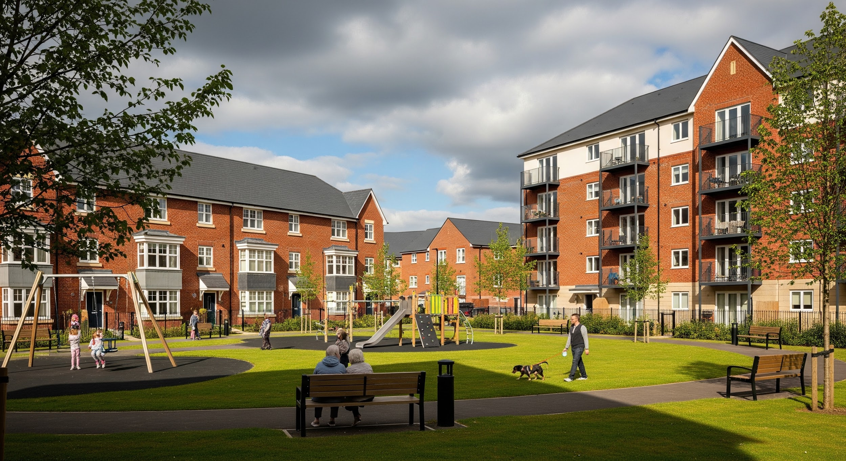
Real estate hardly retains its value by chance. Constructions grow old, materials wear out, and the expectations of tenants change with time. Regular maintenance dictates the difference between the appreciation of an asset and gradual deterioration beyond the surface. Professional management has a decisive role in protecting structural integrity and financial performance.

Investors tend to undervalue the rate at which capital growth is being eroded by negligence. Minor flaws can develop into significant spending when neglected. The decision to change property factors is often made by the owners after it is realised that competent stewardship will drive resale and rentability. Effective management introduces order, responsibility and vision to what could otherwise be a reactive process.

Strategic Maintenance Planning
Asset preservation begins with proper planning. Experienced managers employ inspection schedules where wear is anticipated instead of waiting until it is noticed. External finishes, shared electricity, drainage systems and roof covers should be evaluated periodically.

When preventive action is taken, emergent repairs are unlikely to occur. The prompt response to the initial warning signs prevents the escalation of minor degradation into structural damage. Proper records also give assurance to the surveyor and prospective purchasers as they indicate that a building has been well maintained.

Long-term schedules make accurate expenditure forecasting possible. Financial stability is strengthened by predictability, especially in multi-occupancy complexes where communal works are financed by combined payments.

Preventative Care Versus Reactive Repairs
As a rule, the planned interventions are relatively cheaper in comparison with the emergency call-outs. Contractors tend to increase prices in pressure situations, especially when specialised goods are required urgently. Planned maintenance will avoid unnecessary bills and minimise inconvenience to the occupants.

Problems such as faulty wiring or moisture damage are identified in routine inspections before safety issues arise. By addressing problems in their initial stages, managers protect occupants and maintain their confidence in the state of the building.

Financial Oversight and Budget Forecasting
Value preservation calls for far more than just physical maintenance. Transparent accounting guarantees that money is distributed properly and supports stakeholder trust. Comprehensive budgets list expected expenses, backup funds, and set-aside funds for upcoming initiatives.

Reserve funds are very useful when large-scale projects are required. Renovating windows, replacing lifts, or doing external renovations all cost a lot of money. A steady build-up of resources reduces owner disputes and avoids unexpected financial distress.

Credibility is increased by transparent reporting. Well-organised accounts indicate careful management when buyers examine service charge histories. Consistent supervision is frequently viewed as a sign of reduced risk by lenders and valuers.

Protecting Rental Income Streams
A stable occupancy rate has a direct impact on asset performance. Tenants expect well-maintained, secure housing that is worth their monthly rent. Neglected common areas or postponed repairs may promote turnover, resulting in longer void times and higher marketing expenses.

Maintenance requests are promptly coordinated by competent managers. Reliability is demonstrated by effective problem solving, which promotes tenant retention. Revenue is stabilised since happy tenants are more inclined to extend their leases.

Income is further protected by adherence to safety requirements. Legal criteria must be followed when doing electrical testing, gas inspections and fire alarm maintenance. Failure to comply with legislative criteria might result in fines or limits on rental, reducing profitability.

Enhancing Market Appeal
Perception is shaped by presentation. Well-kept landscaping, well-lit entrances, and functional lighting all affect how potential buyers or tenants see a property. An atmosphere that is well-presented conveys expertise and care.

Rental potential can be increased through refurbishment plans that are informed by market research. It is frequently possible to increase appeal without requiring significant structural changes by updating entry systems or community décor. In congested urban markets, strategic investment results in a competitive advantage.

Risk Management and Regulatory Compliance
The legal requirements pertaining to residential and commercial properties are always changing. It is necessary to continuously check building rules, data protection standards, and health and safety requirements. Documentation is kept up to date and easily accessible through professional oversight.

Careful consideration must also be given to insurance plans. Accurate reinstatement assessments and extensive coverage safeguard owners against unanticipated emergencies. Investors may suffer significant financial losses as a result of inadequate policies.

Another layer of protection is dispute settlement. If managed improperly, disputes between co-owners, contractors, or tenants can easily get out of hand. By offering unbiased mediation, seasoned managers lessen the potential for expensive legal actions.

Long Term Asset Appreciation
Capital growth is determined by reputation as much as structure. Buildings that are characterised by regular care are more likely to attract high offers at the time when they are sold. Survey reports that depict organised maintenance histories tend to have a bearing on negotiations, favouring the seller.

Buyers also consider not only the present state but also the signs of planning. Compliance certificates, financial forecasts, and detailed maintenance logs are the indicators that an asset has been administered responsibly. Confidence will translate into enhanced valuations.

Worth can be further enhanced by strategic additions made over the years. Upgrades in energy efficiency, security and modernisation of communal facilities are all responsive to changing expectations. These types of improvements make a property competitive in the long run.

Professional property management is not just administration. It combines planning, financial discipline, regulatory consequences, and responsive service into a unified structure. With structured supervision, the owners safeguard not only present revenues but future capital gains as well. Real estate may appear static from the outside, yet sustained value relies on active stewardship behind the scenes.

